**Detailing**

* **Create VMs along with virtual network, subnet for East US**

**vmEastUS** configuration

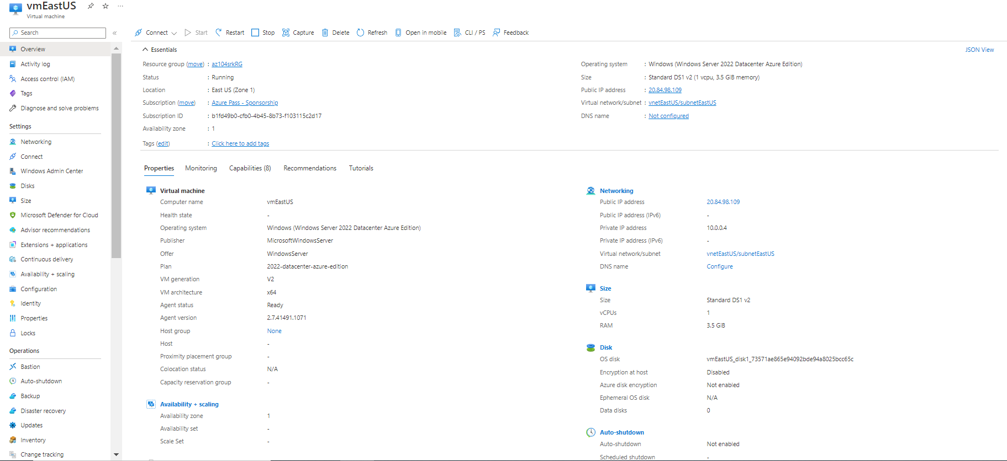

* **Create VMs along with virtual network, subnet for South East Asia**

**vmSouthEastAsia** configuration

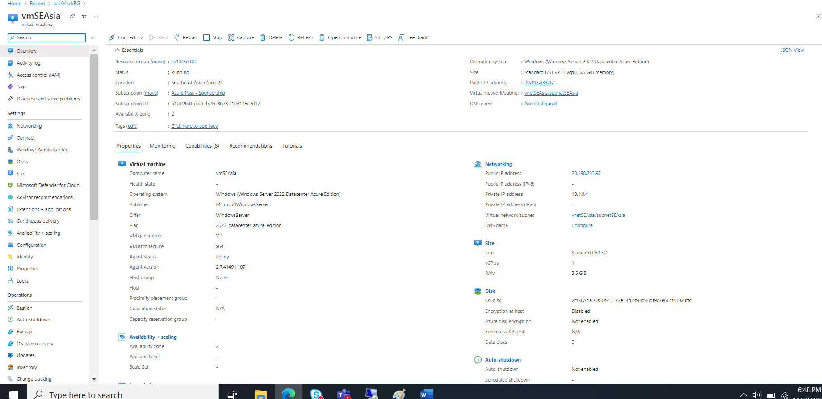

**Topology for VNET EastUS along with Subnet, VM, NIC & VM  
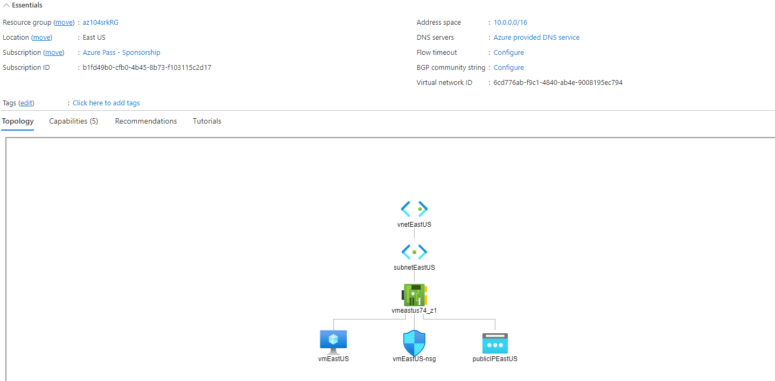**

**Topology for VNET South East Asia along with Subnet, VM, NIC & VM  
VNET South East Asia  
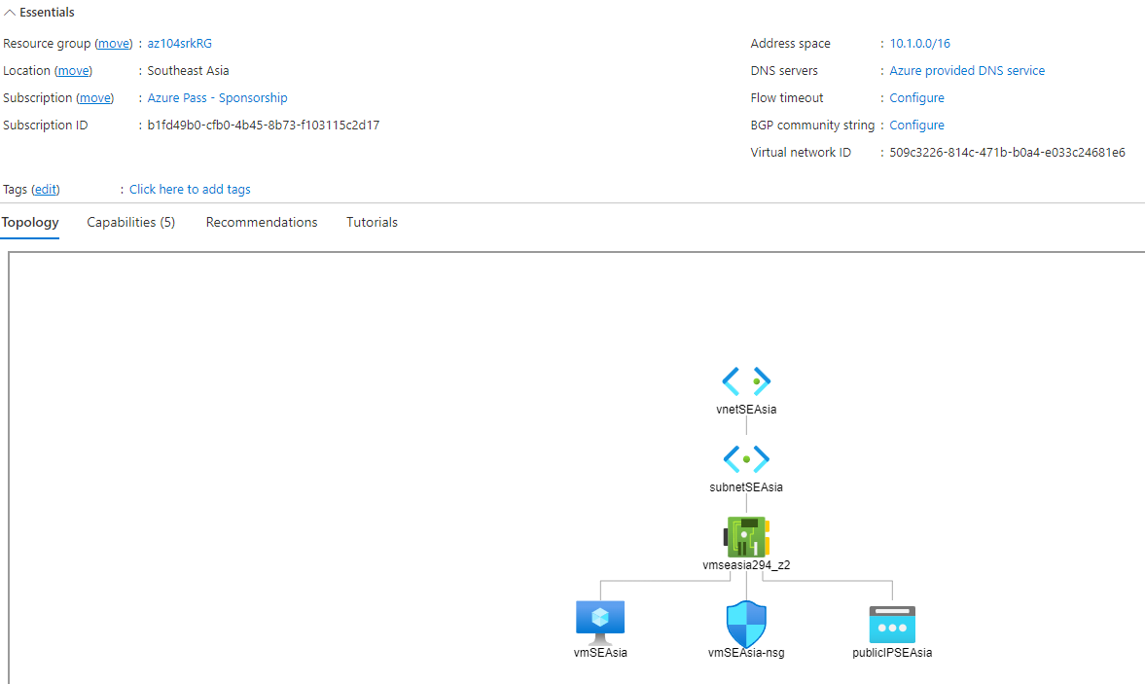**

**Demo for VNet without Peering**

**Without** VNetPeering

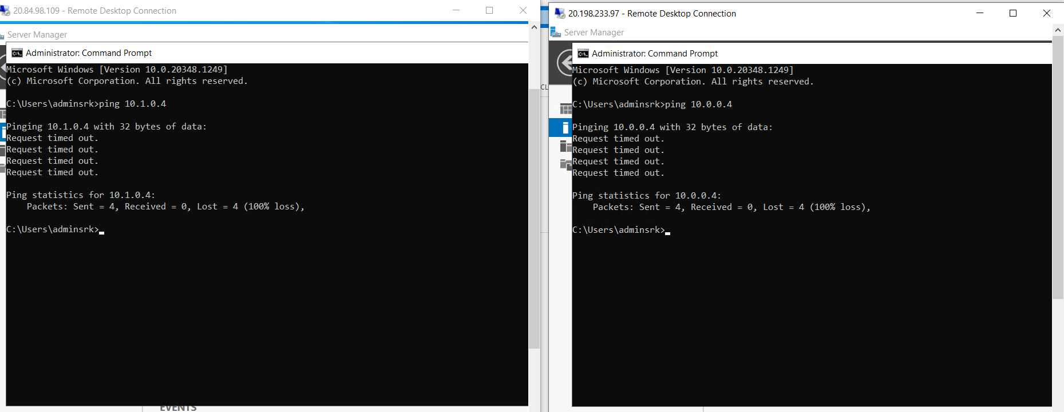

**VNET configuration between 2 regions**

**VNETPeering Configuration (EastUS to SE Asia) VNETPeering Configuration (SE Asia to East US)**

|  |  |
| --- | --- |
|  |  |

**Demo for VNet with Peering**

**With** VNetPeering

